2008 HSC Half Year
Marking Guidelines

1 | 2 | 3 | 4 | 5 | 6 | 7 | 8 | 9 | 10 | 11 | 12 | 13 | 14 | 15
A | A | D | A | B | B | C | D | B | D | A | C | C | D | D

Quest | Sample Answer | Marking Scheme
16 (a) (i) | any TWO of Mg, Al, Zn, Fe, Ni, Sn or Pb | Must have 2 for 1 mark
16 (a) (ii) | Oxidation half reaction Mg(s) ↔ Mg²⁺ (aq) + 2e  Reduction half reaction 2H^{+(aq)} + 2e ↔ H_{2 (g)} | 1 for each correct oxidation and reduction equation
16 (a) (iii) | Redox cell reaction Mg + 2H⁺ ↔ Mg²⁺ + H₂ | Correct combination of half cell reactions to overall redox cell reaction (depending on metal chosen) with states.
16(b) (i) | 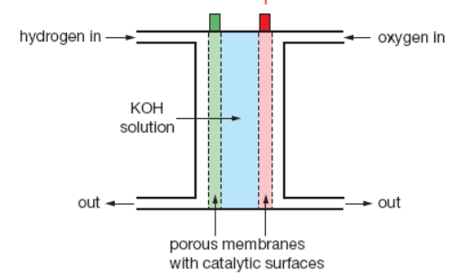  Must label – terminal (H2) and + terminal O2 | Correct sketch that represents accurate diagram of cell, correct labelling of electrodes, electrolytes, and terminals (-1 each error)  NB Identify, by name the cell chosem
16(b) (ii) | Cause: H₂ + 2OH⁻ → 2H₂O + 4e⁻  Effect: The oxidation reaction involving hydrogen gas and the hydroxide ion provides the electrons for the reaction.  Cause: O₂ + 2H₂O + 4e⁻ → 4OH⁻  Effect: The reduction reaction results due to the electrons provided at the anode to produce hydroxide ions.  These reactions above produce water.  2H₂ + O₂ → 2H₂O  - Description to include at least an understanding of electrodes (porous carbon with a catalyst surface)and the fact they don’t undergo change with electrode reactions  - the cell can work indefinitely as long as fuel is supplied  - electrolyte, gets diluted and must be replenished | 3 Marks  Correct half equations and correct net equation (1 mark) and description of the reactions (2 marks)
17 (a) (i) | An acid is a substance, that in solution, tends to donate protons, and a base is a substance that tends to accept protons. | 1 all correct
17 (a) (ii) | Cause: the hydrogen carbonate ion is amphiprotic.  Effect: In the first reaction, HCO₃⁻ is acting as a base as it accepts H⁺ to form H₂CO₃; in the second reaction, HCO₃⁻ is acting as an acid as it donated a proton to form CO₃²⁻. | 1 mark each reaction
17 (b) (i) | Cause: The concentration of an acid refers to the amount of solute in a volume of solution  Effect: Thus hydrochloric acid is less concentrated as 0.001 is lower in conc than 0.56 | 1 mark qualitative  2 marks quantitative
17 (b) (ii) | Cause: The strength of an acid refers to the degree of ionisation or dissociation in solution.  Effect: Ethanoic is less ionised in solution and thus is the weaker acid. Using this information, it is only 1.8% ie (0.001÷0.056)x100 ionised while HCl is 100% ionised. | 2 marks must be quantitative with working
17 (b) (iii) | Cause: Since the pH, which is a measure of hydrogen ion concentration,  Effect: Each acid is the same, the hydrogen ion concentration in solution must be the same.  [H⁺] = 10^{-pH}  = 10⁻³  = 0.001 mol/L | 2 marks must be quantitative with working with the correct explanation
18 (a) | - Ethyl ethanoate | 1 mark – identifies the ester made.
18 (b) | *  CH₃COOH + CH₃CH₂OH ↔ CH₃COOCH₂CH₃ + H₂O  * concentrated sulphuric acid + heat under reflux. | 1 marks – balanced equation
18 (c) | Add together 5mL of ethanol, 6mL of ethanoic acid and 8 drops of sulphuric acid in a quick fit reaction flask that can be connected to a water cooled condensor. Justification: The concentrated sulphuric acid acts as a catalyst and speeds up the rate of reaction. It also absorbs water therefore drives the above equilibrium to the right and increases the yield of ester. Add a couple of glass boiling chips. Justification: Dispersal of heat to ensure even heating and prevents bumping.  Heat in a hot water bath under reflux for 20 minutes. Justification: The hot water bath provides a constant heating temperature of 100°C around the flask which also ensures even heating. This increases the rate of reaction and results in a higher yield.. A Bunsen flame used directly would be too hot and as the reactants are flammable and volatile they maybe ignited by the flame. Reflux ensures that as reactants evaporate, they then get condensed and return to the reaction flask.  After refuxing for 20 minutes distill and collect the fraction that evaporates at 75-85°C. Justification: In the reaction flask is a mixture of ethyl ethanoate, ethanol, ethanoic acid and sulphuric acid. Distillation helps separate the ester as this is the temperature it evaporates.  Pour distillate into a separating funnel and add sodium carbonate until gas stops evolving. Justification: The sodium carbonate reacts with left over ethanoic acid and sulphuric acid that escaped into the distillate. The sodium carbonate reacts to produce salt, carbon dioxide and water.  Example: CH₃COOH + Na₂CO₃ ↔ CH₃COO⁻ Na⁺ + CO₂ + H₂O  Separate by opening the tap of the funnel and release the aqueous layer. Justification: The oily layer is on top and is the ester. After releasing the aqueous layer, all that is left in the separating funnel is the ester. | 3-4 marks  - detailed description of necessary equipment and the refluxing process or suitable diagram.  - Justification given for all equipment, chemicals (including catalyst, must say conc sulphuric acid) and refluxing.  2 marks  - Describes equipment and refluxing process or draws a diagram.  - Identifies some chemicals and gives at least one reason for a piece of equipment.  1 mark  Outlines some chemicals or equipment
19 | The addition of metabisulphite (S₂O₅²⁻) increases the concentration of of HSO₃⁻ as shown in the first equation. The second equation shows an equilibrium reaction. The system adjusts to overcome this increase in the concentration of HSO₃⁻ by favouring the forward reaction. This causes the concentration of H₃O⁺ to decrease and the pH to increase. | 3-4 marks  Clearly demonstrates a quantitative understanding of pH as it relates to [H₃O⁺]AND explains the effect of a decrease in [H₃O⁺] concentration with reference to the second equation.  2 marks  Demonstrates an understanding of pH as it relates to [H₃O⁺] AND explains the effect of a decrease in _{[H3O+]}concentration with reference to the second equation.  1 mark  Identifies the pH change as becoming more basic or less acidic
20 (a) | CH₃COOH (aq) ↔ CH₃COO⁻ (aq) + H⁺ (aq) | Must have states and equil arrow.
20 (b) | 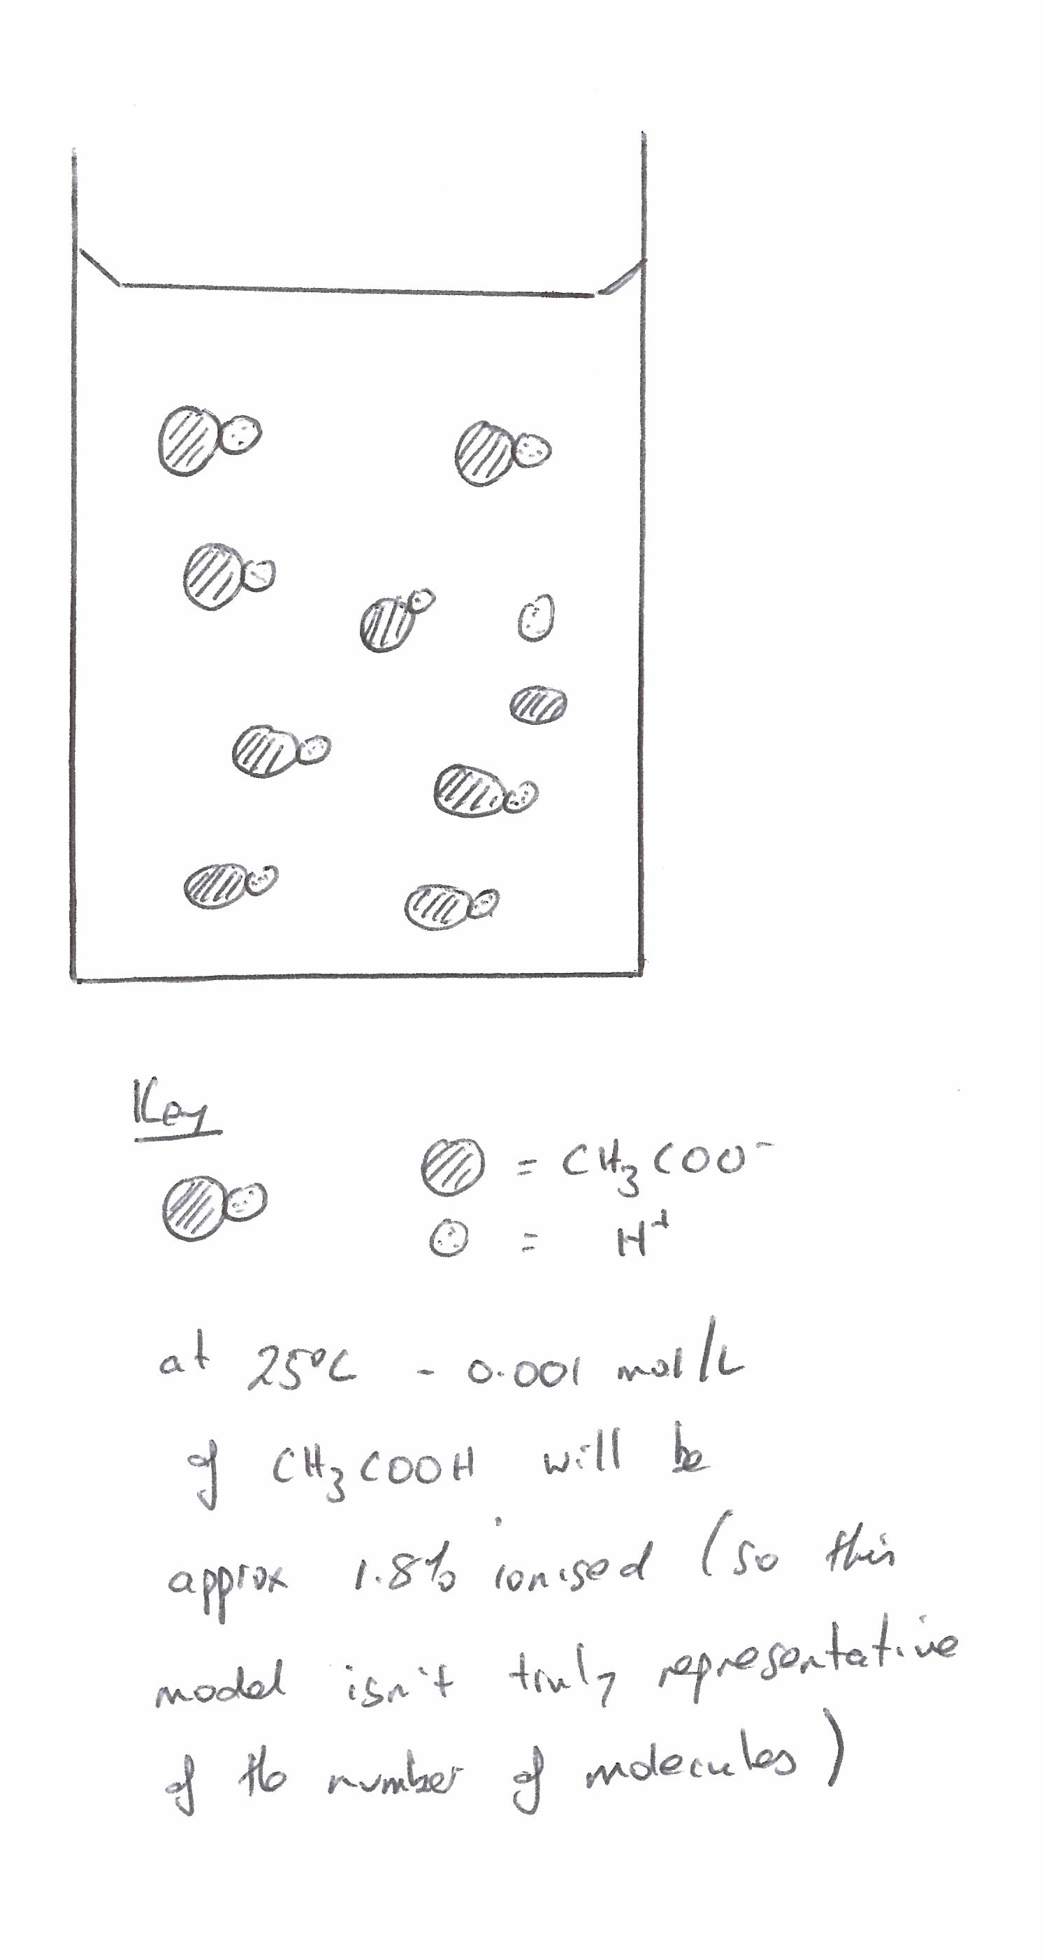 | Must be quantitative
21 | (i)  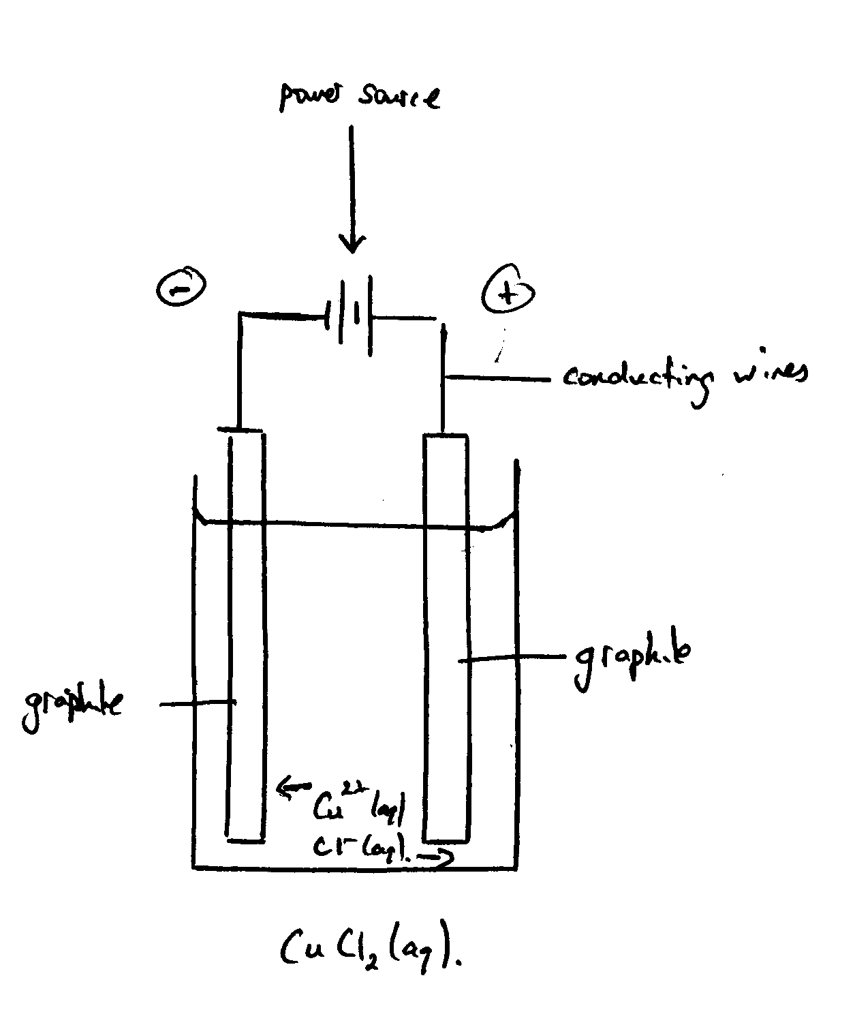  (ii) 2H₂O(l) → O₂ (g) = 4H⁺ (aq) + 4e⁻  Gas produced is oxygen gas  (iii) Cu²⁺ + 2e⁻ → Cu +0.34V  Cl⁻ → Cl₂ + 2e⁻ -1.36V  Cu²⁺ + 2Cl⁻ → Cu + Cl₂ -1.02V  So a voltage greater than 1.02V must be applied.  - The negative electrode (cathode) increases in mass due to the deposition of copper because of the reduction of copper ions. The blue colour of the solution diminishes due to the reduction of the blue copper ions.  (b)  (i) Oxygen concentration decreases (then increases in some areas)  NB Cause: Effect  - Cause: Lot of oxygen at surface At the surface there is a lot of photosynthetic organisms producing oxygen and high partial pressure of oxygen above water results in oxygen dissolving. [1 mark]  : As depth increases, less photosynthetic organisms but many organisms respiring and using oxygen causing it to decrease.[1 mark] (At great depths water from Arctic and Anatatric regions feeds in. This water is high on oxygen hence concentration increases slowly.)  Work of Early Scientists  Galvani  Galvani discovered effect of static charge and electric currents on muscles and nerves in frogs. Frog muscles contracted when the spinal cord was connected to iron with a copper hook. Twitching occurred when the nerve was touched with different metals. Conclusion was the tissues contain an electric fluid called “animal electricity” as no external source of electricity was involved. Believed the brain created the fluid and nerves conducted the fluid to muscles which were stimulated by it.  Volta  Repeated and extended his experiments with frogs legs based on extending the idea of whether the electricity was in the muscle or arose from the metals connected by moist salty flesh of frogs leg. He tested different metals and the twitching got stronger as the similarity between the metals decreased. Described Galvani’s “animal electricity” as “metal electricity”. So concluded that “life, tissue or a vital force” not responsible but it was the metals. The salty environment from the frogs led connected the metals. Metal contact theory important lead into electrochemistry.  Davy  Developed the voltaic pile to create a bigger battery and electrolysed water. Electrolysed molten KOH and NaOH to produce K and Na.  after realizing aqueous solutions only produced hydrogen and oxygen gas. Went on to isolate Sr, Ca, Mg, Ba Electric current through molten salts, resulting in reduction reactions to produce metals. Electrolyte used regulates the substance formed at each electrode. Compounds contained charges particles which conduct electricity by moving to the opposite charged electrode. An electric force holds compounds together  Faraday  Electrolytic reactions leading to the development of the Faraday’s Laws of Electrolysis. Amount of an element produced (quantitative analysis) by electrolysis dependent on quantity of electricity passed through the circuit, the atomic mass, the element and the valency. Quantitative laws supported the concept at the time that electricity was a particle (electron). Electrolyte theory that salts break up and the resulting charged particles move to the opposite electrodes. Terms such as anode, cathode, anion, cation, electrode and electrolysis which helped his descriptions of the experiments he carried out.  Impact on society  The above shows the work done by each scientist in assisting in an understanding of electron transfer reactions. With this knowledge came significant impacts on society such as:  - Portable forms of electricity enabling operation of devices such as torches.  - Isolation of metals through electrolysis eg copper to be used in electrical wiring  - Transport is electricity dependent, as is heating lighting, enetertainment  (d)  (i) Set up test tubes according to the following table  Results  Scale of 0-5 of corrosion, measured by recording appearance and size of metal after all metals being submersed for exactly 24 hours.  0 = no reaction  1 = very small amount corrosion  2 = small amount of corrosion  3 = moderate corrosion  4 = significant corrosion  5 = high corrosion  (ii)  Identify: Acidic solutions  Assess: Acidic solutions are corrosive to the skin.  Control: Use a dropper to carefully transfer the acid to t5he test tube to minimise splashing upon transfer. Wear gloves as a final protection measure.  (iii)  In the experiment metal corrosion was significantly accelerated in the acidic environment as compared to the neutral environments. The higher the acid concentration, the greater the rate of corrosion the metal. The more reactive Mg corroded faster than the Fe.  Iron corrosion can be used to explain why this is the case.  Iron oxidises according the following equation:  Fe _{(s)} ↔ Fe²⁺ _{(aq)} + 2e⁻  The reduction reaction possibilities are as follows:  O_{2 (g)} + 2H₂O _{(l)} + 4e⁻ ↔ 4OH⁻ _{(aq)} Eº (red) = +0.40V ………1  O_{2 (g)} + 4H⁺ _{(aq)} + 4e⁻ ↔ 2H₂O _{(l)} Eº (red) = +1.23V ………2  The acidic environment (eg presence of SO_{2 (g)} due to human activity) provides a more spontaneous reaction. Also, the H⁺ ions from reaction 2 react with the OH⁻ ions from reaction 1. This drives the first reaction to the right, therefore increasing the Eº of equation 1. | 2 Marks - Must have electrodes labelled, solutions labelled, electron flow, polarity of electrodes. Subtract 1 for each omission.  1 Mark - Correct identification of gas.  2 Marks - Greater than 1.02V with working  1 Mark - Correct answer with equations but no reference to greater than OR greater than 1.02V but no working OF incorrect answer but correct use of equations.  2 Marks - 2 valid observations with explanations.  1 Mark - 1 valid observation with explanation OR 2 valid observations with no explanation.  1 Mark – Identifies the trend correctly  2 Marks - Full working and correct answer  3-4 Marks  Outlines the work of Galvani, Volta, Davy and faraday in inceasing our understanding of electron transfer reactions AND provides features and characteristics of the impact of this work on society.  2 marks  States the work of at least two of Galvani, Volta, Davy and faraday increasing our understanding of electron transfer reactions OR provides features and characteristics of the impact of this work on society.  1 mark  States the work of at least one of Galvani, Volta, Davy and faraday increasing our understanding of electron transfer reactions  2 marks  Sketches in general terms the relevant procedure identifying all conditions [1] AND shows results [1]  Full RA [1]  Relates results of experiment [1]  Provides correct equations [1]  Correct explanation [1]
  Test tube # | Metal | Vol of Soln | Soln
  1 | 0.5cm² Mg | 5mL | 0.1 mol/L HCl
  2 | 0.5cm² Fe | 5mL | 0.1 mol/L HCl
  3 | 0.5cm² Mg | 5mL | 1.0 mol/L HCl
  4 | 0.5cm² Fe | 5mL | 1.0 mol/L HCl
  5 | 0.5cm² Mg | 5mL | 0.1 mol/L CH₃COOH
  6 | 0.5cm² Fe | 5mL | 0.1 mol/L CH₃COOH
  7 | 0.5cm² Mg | 5mL | 1.0 mol/L CH₃COOH
  8 | 0.5cm² Fe | 5mL | 1.0 mol/L CH₃COOH
  9 | 0.5cm² Mg | 5mL | 0.1 mol/L NaCl
  10 | 0.5cm² Fe | 5mL | 0.1 mol/L NaCl
  11 | 0.5cm² Mg |  | 1.0 mol/L NaCl
  12 | 0.5cm² Fe |  | 1.0 mol/L NaCl
  13 | 0.5cm² Mg |  | Distilled water
  14 | 0.5cm² Fe |  | Distilled water
  Test Tube | Results
  1 | 4
  2 | 3
  3 | 5
  4 | 4
  5 | 3
  6 | 2
  7 | 4
  8 | 3
  9 | 2
  10 | 2
  11 | 3
  12 | 3
  13 | 2
  14 | 2

